
PROGRAMMING 2B
PROG6212


NAMES: NALEDI CHARITY
SURNAME: MOKOENA
ST NUMBER: ST10488132
MODULE: PROGRAMMING 2B
MODULE CODE: PROG6212

SECTION A: ERD

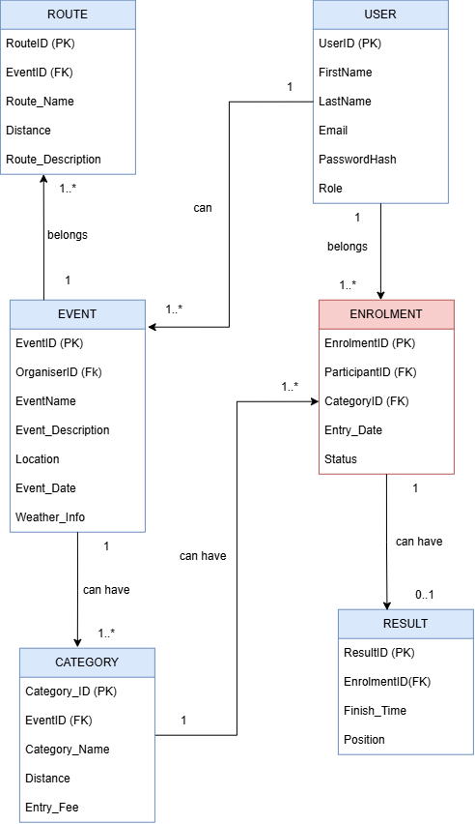
SECTION B: API ENDPOINT

HTTP Method | Route | Description | Role Required | Request Body | Expected Response
POST | /api/auth/register | Register a new user as an Organiser or Participant. | Public | FirstName, LastName, Email, Password, Role | 201 Created – User successfully registered
POST | /api/auth/login | Authenticate a user and return an authentication token. | Public | Email, Password | 200 OK – JWT/token and user role returned
GET | /api/users/profile | View the currently logged-in user's profile. | Organiser / Participant | None | 200 OK – User profile
PUT | /api/users/profile | Update the currently logged-in user's profile. | Organiser / Participant | FirstName, LastName, Email | 200 OK – Updated profile
GET | /api/events | View all upcoming/available events. | Organiser / Participant | None | 200 OK – List of events
GET | /api/events/{id} | View details of a specific event. | Organiser / Participant | None | 200 OK – Event details
POST | /api/events | Create a new event. | Organiser | Name, Description, Date, Location, Distance, EventType | 201 Created – Event created
PUT | /api/events/{id} | Update an existing event created by the organiser. | Organiser | Name, Description, Date, Location, Distance, EventType | 200 OK – Event updated
DELETE | /api/events/{id} | Delete an event owned by the organiser. | Organiser | None | 204 No Content – Event deleted
GET | /api/events/{eventId}/categories | View all categories belonging to an event. | Organiser / Participant | None | 200 OK – List of categories
POST | /api/events/{eventId}/categories | Add an age or distance category to an event. | Organiser | CategoryName, Distance, EntryFee | 201 Created – Category created
PUT | /api/categories/{id} | Update an existing event category. | Organiser | CategoryName, Distance, EntryFee | 200 OK – Category updated
DELETE | /api/categories/{id} | Delete an event category. | Organiser | None | 204 No Content – Category deleted
POST | /api/events/{eventId}/enrolments | Enter an event by selecting a category. | Participant | CategoryID | 201 Created – Enrolment created
GET | /api/users/enrolments | View the logged-in participant's event enrolments. | Participant | None | 200 OK – List of user's enrolments
GET | /api/events/{eventId}/enrolments | View all participants enrolled in an organiser's event. | Organiser | None | 200 OK – List of event enrolments
POST | /api/enrolments/{enrolmentId}/result | Capture a participant's finish time and finishing position. | Organiser | FinishTime, Position | 201 Created – Result recorded
GET | /api/users/results | View the logged-in participant's personal results. | Participant | None | 200 OK – List of personal results
GET | /api/events/{eventId}/results | View results for participants in an organiser's event. | Organiser | None | 200 OK – List of event results

What this API ENDPOINT does:
- It is for User Management: Handles registration, login, and profile updates for Organizers and Participants.
- It is for Event Management: Allows Organizers to create, view, update, and delete events with details like name, date, location, and distance.
- It is for Categories & Enrolments: Enables Organizers to add categories (age/distance) to events, and Participants to enroll in events by selecting a category.
- It is for Results Tracking: Allows Organizers to capture participant finish times and positions, while Participants can view their personal results.

SECTION C:
These are the screenshots to my SQL code:
I created a database named RaceDayDB and created tables
USER TABLE:
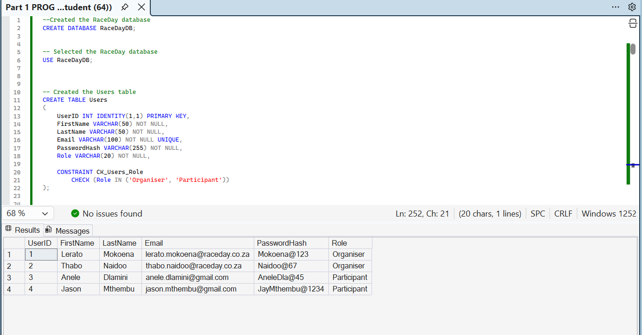
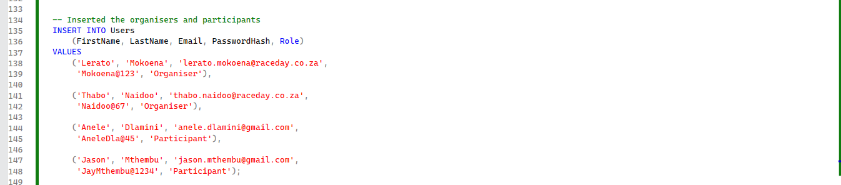
This is the populated code for the user table. Shows the organizers and participants.
EVENTS TABLE:
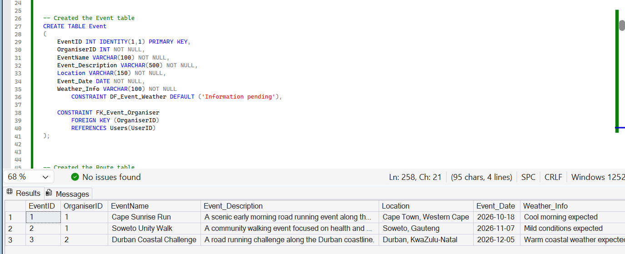
This is the populated code for events table.

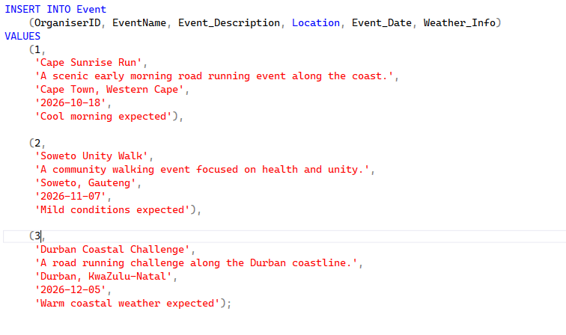
CATEGORY TABLE: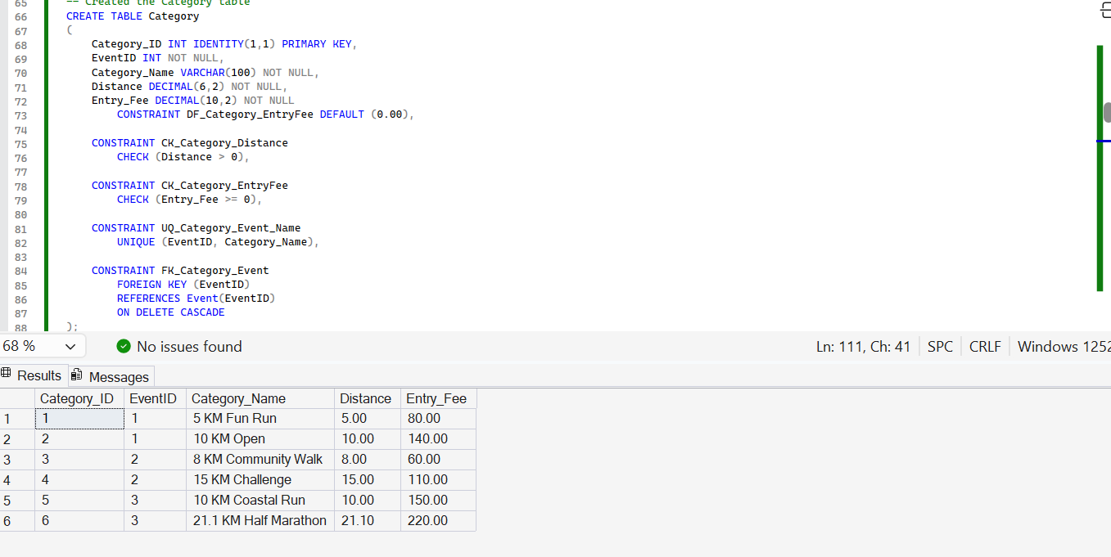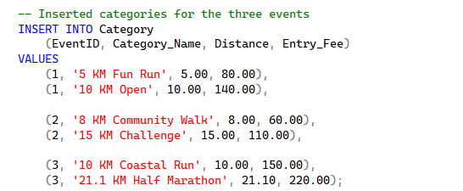
This is the populated code for Category.

ROUTE TABLE:
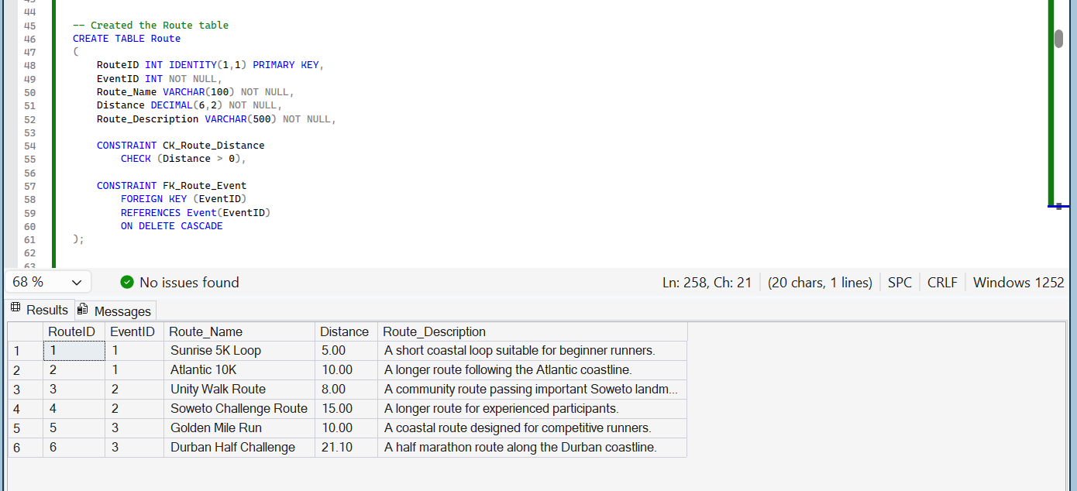
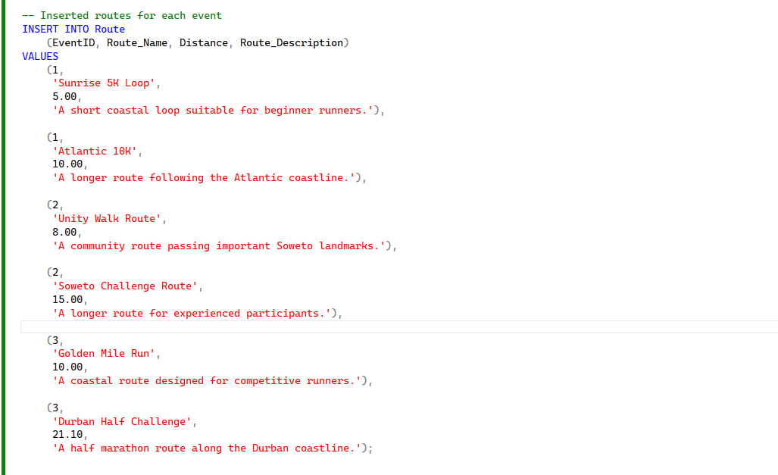
This is the populated code for Route table.

ENROLMENT TABLE:
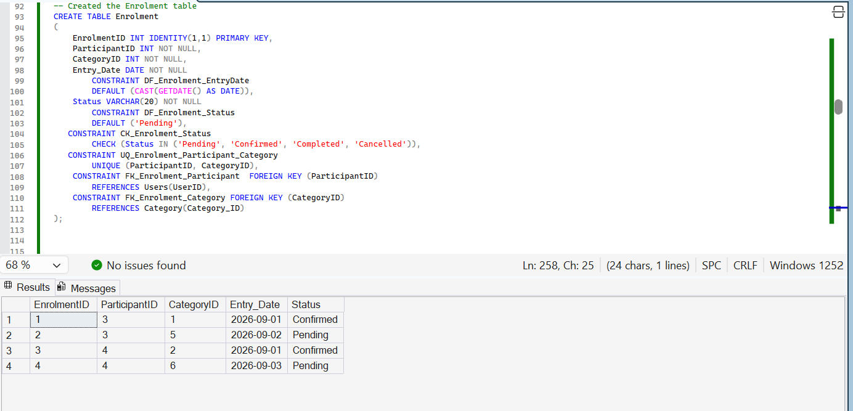

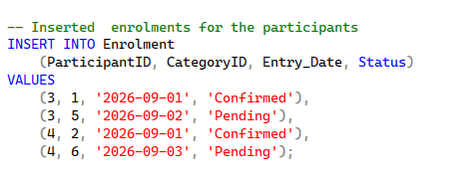
This is the populated code for Enrolment table.

SELECT STATEMENTS TO DISPLAY THE TABLES:
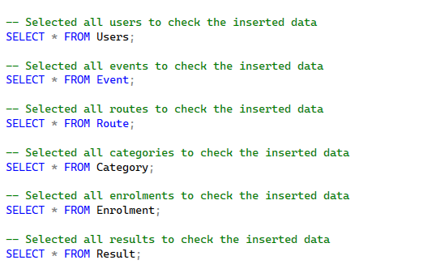
This code will display all the tables when executed.
JOINING ALL THE TABLES TO SEE IF THEY WORK TOGETHER.
